
The Giant Marshmallow

I love S’mores

If I found a marshmallow this big
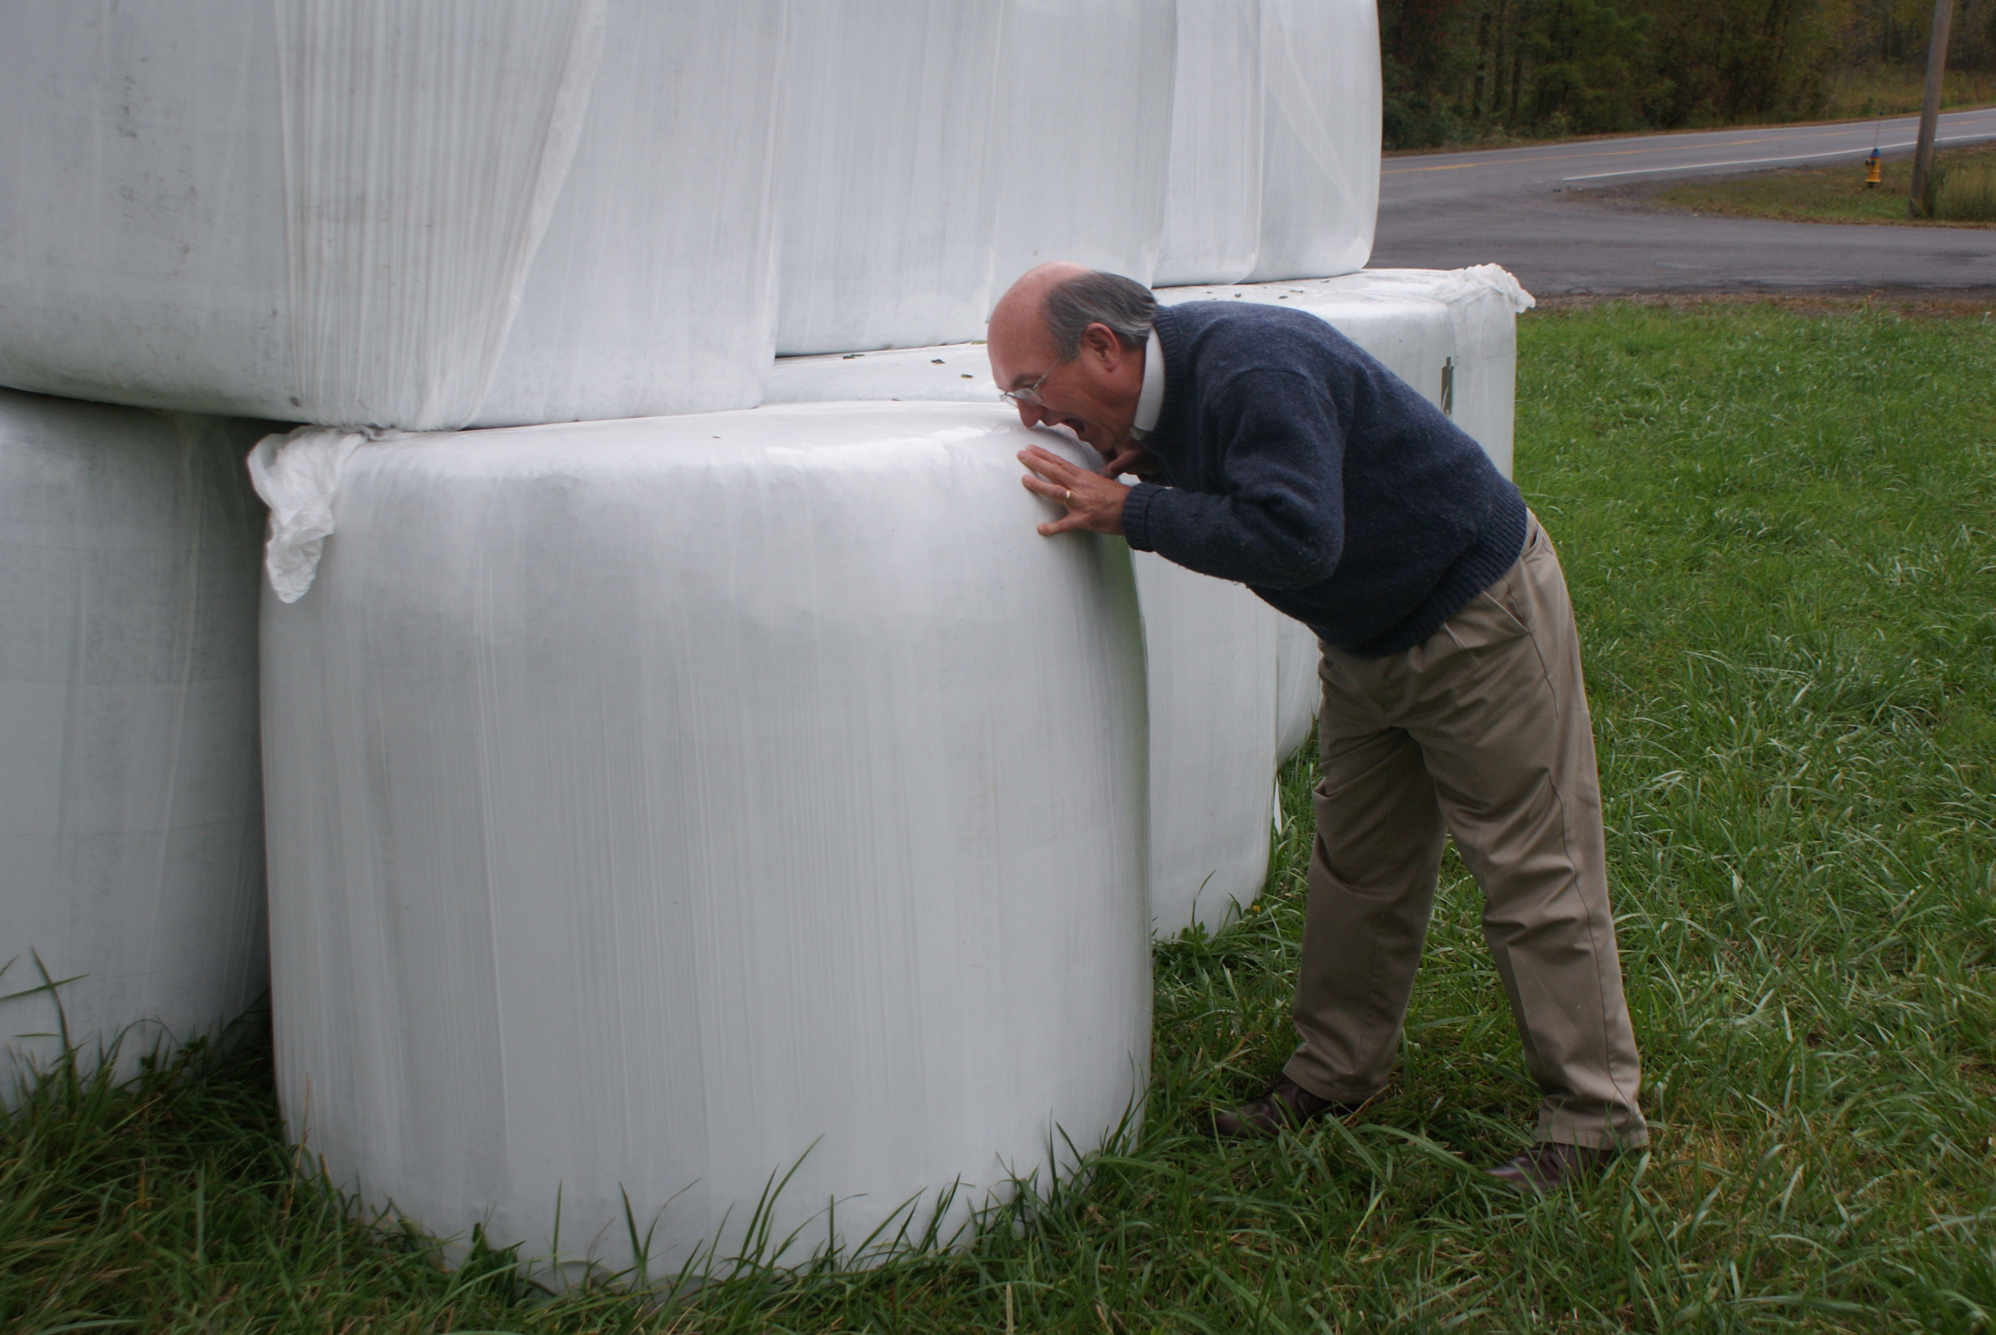

how big would my graham cracker have to be?

Materials:
Normal marshmallows
Normal graham crackers
Rulers

Information:
Diameter of Megamarshmallow 55”
Height of Megamarshmallow 45”

